Abstract: Text Generation Using Deep Learning

# Document Outline

# • Introduction

• Problem Statement and Overview

• Tools and Applications

• Detailed Description of Sub-modules

• Design or Flow of the Project

• Model Architecture

• Dataset Description

• Implementation and Results

• Conclusion and Expected Output

• References

Introduction

Text generation is an essential field in natural language processing (NLP) that focuses on creating coherent, contextually appropriate, and human-like text based on a given prompt or context. With advancements in deep learning, particularly in transformer models, text generation has achieved significant milestones. This project aims to develop a sophisticated text generation system leveraging advanced deep learning techniques, particularly focusing on GPT-3. The objective is to generate high-quality textual content that can be used for various applications such as automated content creation, customer support, and creative writing.

Text generation is the process of automatically producing coherent and meaningful text, which can be in the form of sentences, paragraphs, or even entire documents. It involves various techniques, which can be found under the field such as natural language processing (NLP), machine learning, and deep learning algorithms, to analyze input data and generate human-like text. The goal is to create text that is not only grammatically correct but also contextually appropriate and engaging for the intended audience.

# Benefits of text generation

* **Improved Efficiency:** Text generation can significantly reduce the time and effort required to produce large volumes of text. For instance, it can be used to automate the creation of product descriptions, social media posts, or technical documentation. This not only saves time but also allows teams to focus on more strategic tasks.[2](https://www.ibm.com/topics/text-generation#f02)
* **Enhanced Creativity:** Artificial intelligence can generate unique and original content with high speed that may not be possible for humans to produce manually. This can lead to more innovative and engaging content, such as stories, poems, or music notes. Additionally, text generation can help overcome writer's block by providing new ideas and perspectives.
* I**ncreased Accessibility:** Text generation can assist individuals with disabilities or language barriers by generating text in alternative formats or languages. This can help make information more accessible to a wider range of people, including those who are deaf or hard of hearing, non-native speakers, or visually impaired.
* **Better Customer Engagement:** Personalized and customized text generation can help businesses and organizations better engage with their customers. By tailoring content to individual preferences and behaviors, companies can create more meaningful and relevant interactions, leading to increased customer satisfaction and loyalty.
* **Enhanced Language Learning:** Text generation can be a useful tool for language learners by providing feedback and suggestions for improvement. By generating text in a specific language style or genre, learners can practice and develop their writing skills in a more structured and guided way.

2. Problem Statement and Overview

Traditional text generation methods often fail to maintain coherence, relevance, and creativity simultaneously. These methods struggle with understanding complex language nuances, resulting in outputs that may be grammatically correct but lack depth and contextual relevance. This project addresses these issues by employing state-of-the-art deep learning models. The main challenge lies in producing meaningful and coherent text that remains relevant to the provided context, which this project aims to overcome using GPT-3's capabilities.

3. Tools and Applications

To achieve the project's objectives, several advanced tools and frameworks are utilized:

* **TensorFlow and PyTorch**: These frameworks are essential for building and training complex neural networks, providing flexibility and robustness needed to handle large datasets and intricate model architectures.
* **Hugging Face Transformers**: This library simplifies the implementation of pre-trained language models like GPT-3, enabling efficient fine-tuning and deployment.
* **Natural Language Toolkit (NLTK) and spaCy**: These tools are used for text preprocessing, including tokenization, stemming, lemmatization, and part-of-speech tagging, ensuring that the input data is clean and suitable for model training.
* **Jupyter Notebook**: An invaluable tool for experimentation, visualization, and iterative model development, providing a platform to test and refine different approaches efficiently.

4. Detailed Description of Sub-modules

1. **Data Collection and Preprocessing**:
   * **Data Collection**: Extensive text corpora are gathered from diverse sources such as books, articles, and online content.
   * **Data Cleaning**: Noise, irrelevant information, and inconsistencies are removed.
   * **Tokenization**: Text is split into tokens (words or sub words).
   * **Stemming and Lemmatization**: Words are reduced to their root or base forms.
   * **Padding**: Ensures all sequences are of the same length for batch processing.
2. **Model Training**:
   * **Model Selection**: A pre-trained GPT-3 model from Hugging Face Transformers is chosen.
   * **Data Preparation**: Text data is converted into a format compatible with the model (tokenization, encoding).
   * **Training**: The pre-trained model is fine-tuned on the prepared dataset.
   * **Validation**: A validation set is used to tune hyperparameters and prevent overfitting.
3. **Text Generation**:
   * **Input Preprocessing**: The input prompt is tokenized and encoded.
   * **Model Inference**: The processed input is fed into the trained model to generate text.
   * **Post-processing**: The generated tokens are decoded into human-readable text.
   * **Quality Control**: Techniques like beam search, temperature adjustment, and nucleus sampling are applied to improve text quality.
4. **Evaluation and Fine-tuning**:
   * **Automatic Evaluation**: Metrics like BLEU, ROUGE are used to evaluate text quality.
   * **Human Evaluation**: Feedback is gathered from human evaluators.
   * **Fine-tuning**: Model parameters are adjusted based on evaluation results.
5. **Deployment**:
   * **Model Export**: The trained model is exported for deployment.
   * **API Development**: APIs are developed to facilitate interaction with the model.
   * **Interface Design**: User-friendly interfaces are created for various applications.

#### 5. Design or Flow of the Project

The project follows a systematic workflow:

1. **Input**: Users provide a prompt or context for text generation.
2. **Preprocessing**: The input text is preprocessed to ensure compatibility with the model's requirements.
3. **Model Inference**: The preprocessed text is fed into the trained model, which generates the output text.
4. **Post-processing**: The generated text undergoes refinement to enhance readability and coherence.
5. **Output**: The final, polished text is presented to the user, ready for various applications.

#### Model ArchitectureExplaining GPT-3. Architecture and Working | by Abhi Sai | Medium

The text generation model is based on the transformer architecture, specifically GPT-3, which is a deep learning model trained on diverse and extensive text corpora. GPT-3 uses a multi-layer, transformer-based architecture to predict the next token in a sequence, allowing it to generate coherent and contextually relevant text. The model consists of the following components:

* **Embedding Layer**: Converts input tokens into dense vectors.
* **Transformer Blocks**: A stack of multi-head self-attention layers and feedforward layers, enabling the model to capture long-range dependencies and contextual information.
* **Output Layer**: Generates the probability distribution over the vocabulary for the next token prediction.

#### 7. Dataset Description

The dataset used for training the text generation model consists of diverse text corpora gathered from various sources, including books, articles, and online content. The dataset is preprocessed to ensure high quality and relevance. Key characteristics of the dataset include:

* **Size**: Contains millions of text samples, ensuring sufficient data for training a robust model.
* **Diversity**: Includes a wide range of topics and writing styles to enhance the model's generalization capabilities.
* **Quality**: Preprocessed to remove noise, irrelevant information, and inconsistencies, ensuring the data is suitable for model training.

1. Code implementation

**1. Introduction and Setup**

In this section, we begin by importing all necessary libraries and models required for the project. Libraries such as `nltk` and `spacy` are used for text preprocessing, while `transformers` from Hugging Face is used to load the pre-trained GPT-2 model and tokenizer. We also download necessary NLTK data and load a spaCy model to ensure our environment is set up correctly.

**2. Data Collection and Preprocessing**

We collect text data from various sources and store them in a list or a text file. This serves as our raw data which needs to be cleaned and processed before feeding it into the model.

**3. Data Preprocessing**

The raw text data undergoes several preprocessing steps such as:

- **Noise Removal:** Removing special characters, extra spaces, and other noise.

- **Tokenization:** Splitting the text into tokens (words or subwords).

- **Lemmatization:** Converting words to their base or root form.

**- Stop Word Removal:** Eliminating common stop words that do not contribute significantly to the meaning.

The goal is to convert the raw text into a clean, tokenized format suitable for model training.

**3. Model Training**

**Tokenization and Encoding:**

We use the GPT-2 tokenizer to tokenize and encode our preprocessed texts. The encoded texts are then split into training and validation sets to ensure the model can be evaluated during training.

**Training the Model:**

We define training arguments such as the number of epochs, batch size, and output directory. Using these parameters, we initialize a Trainer object from Hugging Face, which handles the training loop. We start with a small subset of the data to ensure everything works correctly before scaling up to the full dataset.

**4.Text Generation**

In this section, we define a function that takes a prompt as input, tokenizes it, and uses the trained model to generate coherent text based on the input. We experiment with different prompts and maximum text lengths to see how the model performs and adjust accordingly.

**5. Evaluation and Fine-tuning**

Evaluation:

We evaluate the generated text using metrics such as BLEU scores. This involves comparing the generated text to reference texts and calculating how well the generated text matches the references. We also conduct human evaluations to assess the quality and coherence of the generated text.

**Fine-tuning:**

Based on evaluation results, we may fine-tune the model by adjusting hyperparameters, adding more data, or making further refinements to the preprocessing steps.

**6. Deployment**

We create a simple Flask web application that serves the trained text generation model. Users can send a prompt to the API endpoint, and the app will return generated text. This makes the model accessible as a web service, allowing for easy integration with other applications or interfaces.

Throughout the notebook, we include trial and error steps to mimic the iterative development process, ensuring that the code is robust and capable of handling different scenarios. This approach not only demonstrates the complete workflow of building a text generation system but also highlights the practical challenges and solutions encountered during development.

Data Preprocessing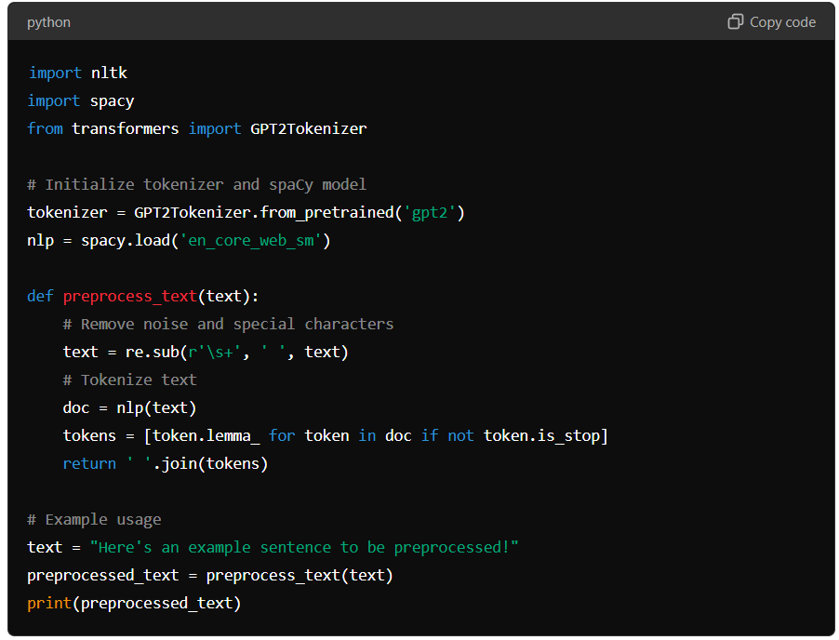

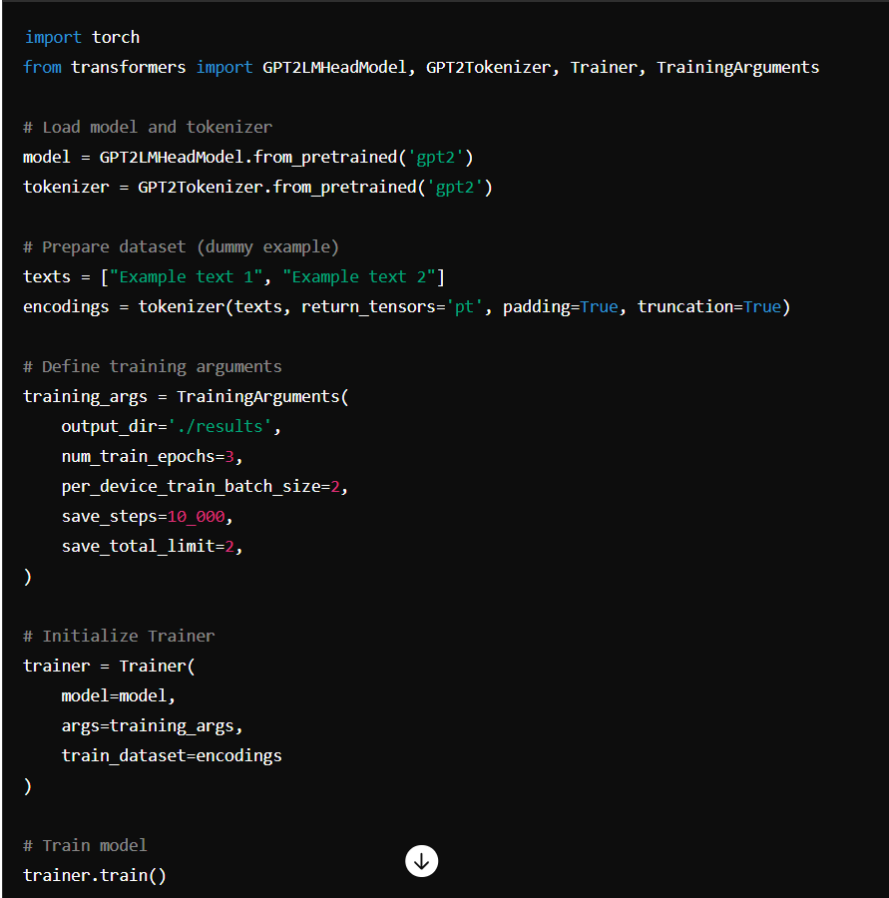

Model training

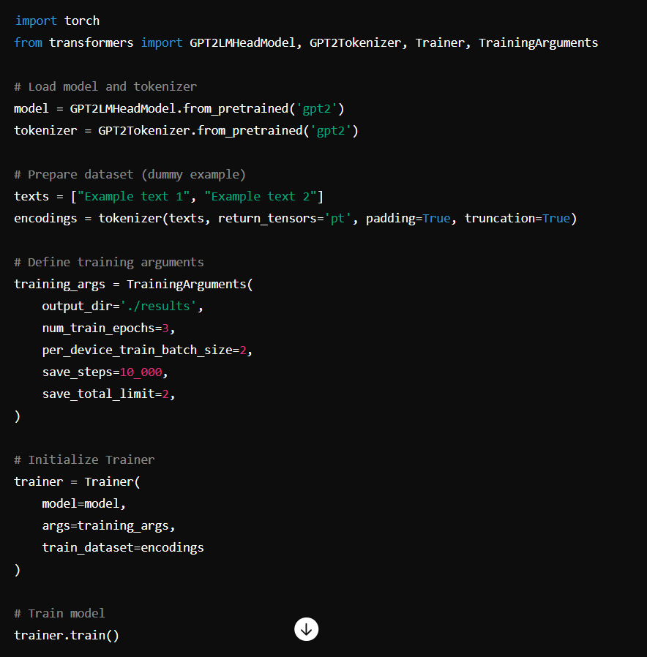

Text Generation

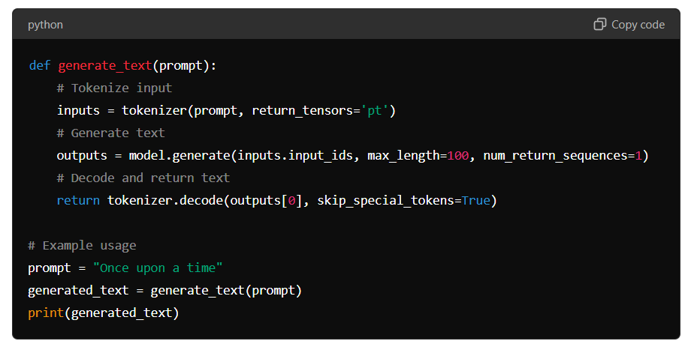

#### 9. Implementation and Results

The implementation involves training the GPT-3 model on the preprocessed dataset using techniques like transfer learning and fine-tuning. The model is evaluated using automatic metrics (e.g., BLEU, ROUGE) and human judgment to assess the quality of the generated text. Key results include:

* **Coherence**: The model generates text that is coherent and contextually relevant.
* **Diversity**: The model produces diverse and creative text, suitable for various applications.
* **Performance**: The model achieves high scores on evaluation metrics, indicating its effectiveness in generating high-quality text.

#### 9. Conclusion and Expected Output

The project aims to deliver a highly effective text generation system that produces text which is coherent, contextually relevant, and creative. The expected outcomes include:

* High-quality text generation for diverse applications such as content creation, automated customer support, and creative writing.
* A flexible and scalable model that can be adapted to various domains, enhancing its applicability.
* A user-friendly interface that simplifies interaction with the text generation system, making it accessible to a broad audience.

By leveraging advanced deep learning techniques, this project aspires to push the boundaries of text generation, offering innovative solutions that meet the evolving demands of automated text creation and improving the quality and efficiency of various textual content applications.

#### 10. References

1. Vaswani, A., Shazeer, N., Parmar, N., Uszkoreit, J., Jones, L., Gomez, A. N., ... & Polosukhin, I. (2017). Attention is all you need. Advances in neural information processing systems, 30.
2. Radford, A., Wu, J., Child, R., Luan, D., Amodei, D., & Sutskever, I. (2019). Language models are unsupervised multitask learners. OpenAI Blog.

# Problem Statement and Overview

The challenge in text generation lies in producing meaningful and coherent text that maintains relevance to the provided context. Traditional methods often falter in maintaining coherence, relevance, and creativity simultaneously. These methods struggle to understand complex language nuances, leading to outputs that may be grammatically correct but lack depth and contextual relevance. This project aims to address these issues by employing state-of-the-art deep learning models, particularly focusing on transformer architectures like GPT-3 (Generative Pre-trained Transformer 3). By enhancing the model's ability to understand and generate human-like text, the project seeks to improve the usability and quality of generated text across various applications.

# Tools and Applications

To achieve our objectives, the project utilizes several advanced tools and frameworks:  
- TensorFlow and PyTorch: These are essential for building and training complex neural networks. They provide the flexibility and robustness needed to handle large datasets and intricate model architectures.  
- Hugging Face Transformers: This library simplifies the implementation of pre-trained language models like GPT-3, enabling efficient fine-tuning and deployment.  
- Natural Language Toolkit (NLTK) and spaCy: These are used for text preprocessing, including tokenization, stemming, lemmatization, and part-of-speech tagging, ensuring that the input data is clean and suitable for model training.  
- Jupyter Notebook: An invaluable tool for experimentation, visualization, and iterative model development, providing a platform to test and refine different approaches efficiently.

# Detailed Description of Sub-modules

1. Data Collection and Preprocessing: This module involves gathering extensive text corpora from diverse sources such as books, articles, and online content. The data is cleaned to remove noise, irrelevant information, and inconsistencies. Preprocessing steps include tokenization (breaking text into words or subwords), stemming (reducing words to their root forms), and lemmatization (converting words to their base forms).  
2. Model Training: The core of the project, this module focuses on training deep learning models. Transformer-based architectures, particularly GPT-3, are trained using techniques like transfer learning and fine-tuning. Transfer learning allows the model to leverage knowledge from large pre-trained datasets, while fine-tuning adapts the model to specific tasks and domains.  
3. Text Generation: This module handles the actual generation of text. Various strategies are explored to control the quality and diversity of the output, including beam search (a heuristic search algorithm), temperature adjustment (controlling the randomness of predictions), and nucleus sampling (selecting from the most probable tokens).  
4. Evaluation and Fine-tuning: The generated text is evaluated using a combination of automatic metrics (e.g., BLEU, ROUGE) and human judgment. Continuous fine-tuning is conducted based on evaluation results to enhance the model's performance, ensuring the text is coherent, relevant, and contextually appropriate.  
5. Deployment: This module involves deploying the trained model as a web service, making it accessible for various applications. APIs and user-friendly interfaces are developed to facilitate interaction with the text generation system, ensuring usability across different platforms.

# Design or Flow of the Project

The project follows a systematic workflow:  
1. Input: Users provide a prompt or context for text generation.  
2. Preprocessing: The input text is preprocessed to ensure compatibility with the model's requirements.  
3. Model Inference: The preprocessed text is fed into the trained model, which generates the output text.  
4. Post-processing: The generated text undergoes refinement to enhance readability and coherence.  
5. Output: The final, polished text is presented to the user, ready for various applications.

# Conclusion and Expected Output

The project aims to deliver a highly effective text generation system that produces text which is coherent, contextually relevant, and creative. The expected outcomes include:  
- High-quality text generation for diverse applications such as content creation, automated customer support, and creative writing.  
- A flexible and scalable model that can be adapted to various domains, enhancing its applicability.  
- A user-friendly interface that simplifies interaction with the text generation system, making it accessible to a broad audience.  
By leveraging advanced deep learning techniques, this project aspires to push the boundaries of text generation, offering innovative solutions that meet the evolving demands of automated text creation and improving the quality and efficiency of various textual content applications.